**SE 421 Fall 2021 Assignment 3 (15 points), Assigned: 09/08, due: 9/15**

**Name (Last, First): Ogbondah, Chimzim**

**Submission**: (a) The answers should be typed. (b) The first page should include the top two lines with your last and the first name. (c) The question should be included for every answer. (d) The file should be named HW1-lastname-firstname. Submit the homework through Canvas.

Similar examples are in the lecture notes. The examples were further elaborated during lectures. Read the notes carefully. In case you missed any lecture, listen to it. Studying notes and attending lectures would be very helpful for the homework. The submission and late policy are as described in the syllabus.

**Problem 1 (7 points):** Answer the following questions using the given code.

1. List the successors in a table using line numbers. (2 points)

|  |  |
| --- | --- |
| **Statement** | **Successor** |
| 2 | 3 |
| 3 | 4 |
| 4 | 5 or 7 |
| 5 | 9 |
| 7 | 22 |
| 9 | 10 or 12 |
| 10 | 14 |
| 12 | 22 |
| 14 | 15 or 17 |
| 15 | 24 |
| 17 | 18 |
| 18 | 19 |
| 19 | 20 |
| 20 | 21 |
| 21 | Exit |
| 22 | 23 |
| 23 | 25 |
| 24  25 | 25  Exit |

1. Give the compact representation (CFG) using the successor relation. (2 points)

1. Give the number of branch nodes in the compact representation. (1 point)
   1. **3**
2. Is there a memory leak vulnerability ( [CWE-401](https://cwe.mitre.org/data/definitions/401.html) ) in the above program, if yes, write the execution sequences using line numbers which leads to the memory leak. (2 points)
   1. 2 3 4 5 9 10 14 15 24 25

**Problem 2 (4 points):** Index XINU in Atlas. Answer the following two questions for the functions *dskqopt* and *ethinter*

1. Create and save the CFG using Atlas and include them as your answer. (2 point)

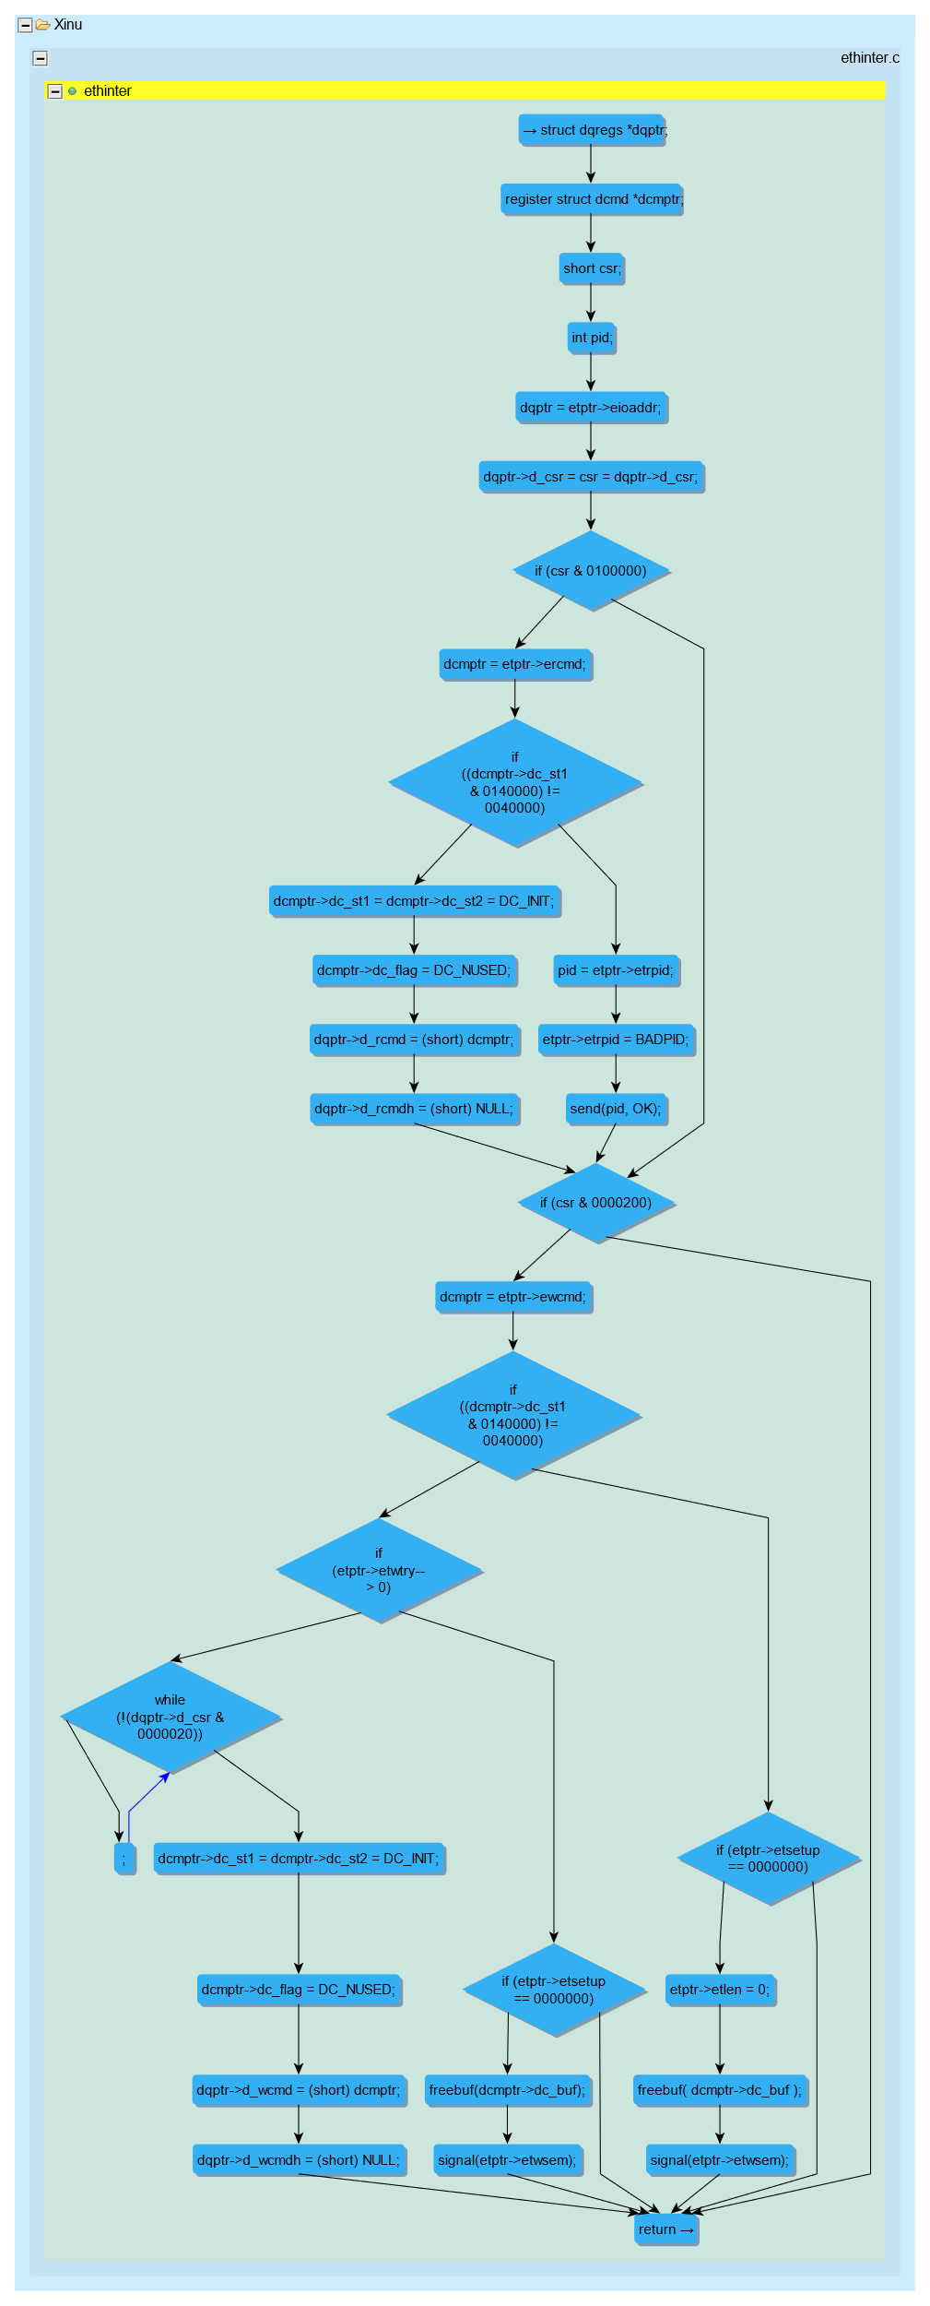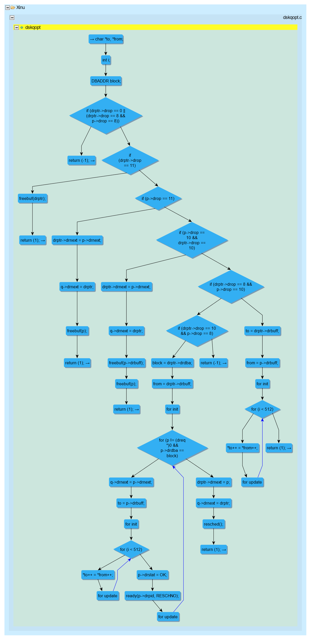

1. Give the following stats for both the functions: #nodes, #edges, #branch nodes, #loops (2 points)
   1. Dskqopt
      1. **Loops: 3**
      2. **Branch nodes: 9**
      3. **Edges: 46**
      4. **Nodes: 37**
   2. Ethinter
      1. **Loops: 1**
      2. **Branch nodes: 8**
      3. **Edges: 42**
      4. **Nodes: 26**

**Problem 3 (4 points):** Answer the following questions for the C program given in the problem 1.

1. Create a C project for the program in Eclipse and index it. (1 point)
2. Create and save the CFG using Atlas and include it as your answer. (1 point)

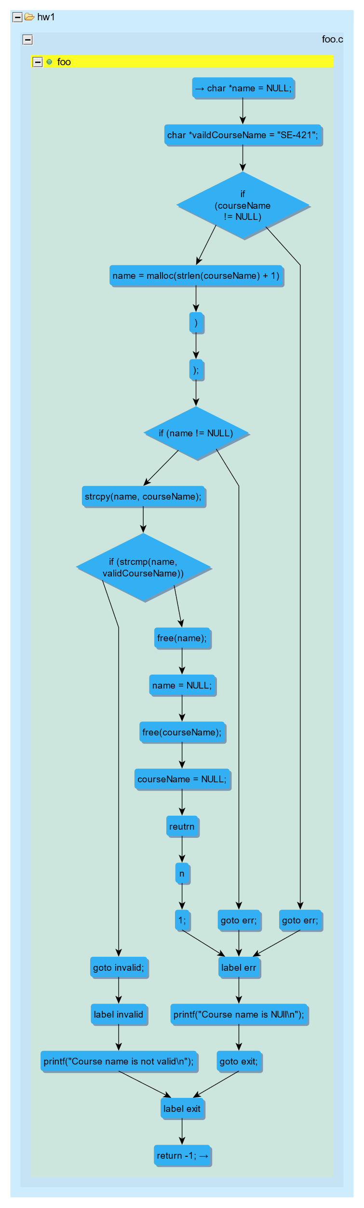

1. Give the following stats for the function foo using Atlas Queries: #nodes, #edges, #branch nodes, #loops. Include the screenshot of the Atlas Shell which shows the stats. (2 points)
   1. **Loops: 0**
   2. **Branch Nodes:3**
   3. **Nodes: 23**
   4. **Edges: 28**